<!--This file created 2:29 PM 10/29/97 by Claris Home Page version 2.0-->1.2 Project
A Broken Tree

A 50-ft tree stands 10 feet from a 10-ft fence. The tree is suddenly "broken" at a height of x feet (Fig. 1.2.33). You are to determine the height x such that the tree falls so that its trunk just barely touches the top of the fence when the tip of the tree strikes the ground on the other side of the fence.

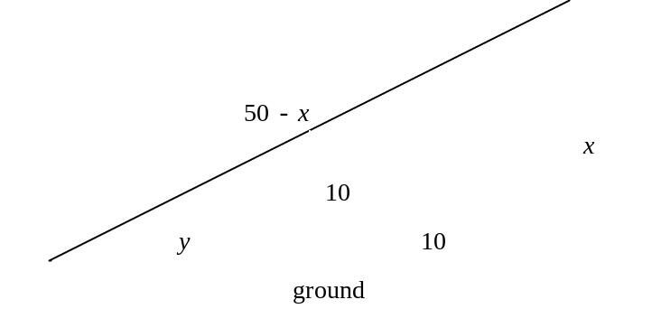

Upon equating base/height ratios in the smaller and larger similar right triangles in this figure, we get
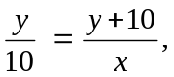
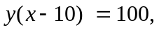
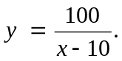 (1)

Also, the Pythagorean theorem applied to the larger right triangle yields

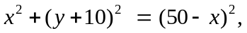
so
(2)

The graph of Eq. (1) is a translate — 10 units to the right — of the rectangular hyperbola 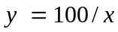 that looks (aside from y-axis scale) like the rectangular hyperbola 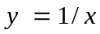 shown in Fig. 1.2.12 of the text. The graph of Eq. (2) is a translate or the leftward-opening parabola 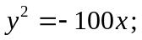our parabola has its vertex at the point 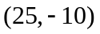rather than the origin.

Our rectangular hyperbola and parabola are graphed simultaneously in Fig. 1.2.34 in the text. We see three intersection points. Because x is the positive height of the tree break, the third quadrant intersection point with x negative does not correspond to a physically broken trees. However, the two first-quadrant intersection points satisfy Equations (1) and (2) as well as the condition that x be positive. They lie on the "upper half"
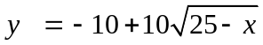 (3)

of the parabola obtained by solving (2) for y and taking the positive square root. (The negative square root would give the lower half of the parabola.)

You can use a graphing calculator or computer to locate the two pertinent points of intersection of these two graphs. That is, graph Eqs. (2) and (3) simultaneously, and then zoom in on each of the two points of intersection. You should find that the two positive solutions for x are 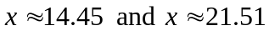 (accurate to 2 decimal places). Thus there are two possible positions of the broken tree as described originally! It might be interesting to calculate the two corresponding values of y given by Eq. (1), and then make scaled drawings illustrating the tree with "high and low breaks".

For your own personal investigation, begin instead with a tree of height 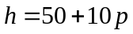 feet, where p denotes the last nonzero digit in your student ID number. Write up the results of your investigation in the form of a carefully organized report consisting of complete sentences (including pertinent equations and figures). Explain your results in detail and tell precisely what you did to solve the problem posed. Don't just "solve the equation"! Answer the original question completely as to the possible height or heights at which the tree can be broken in order to fit the physical picture.

The sections below illustrate the use of graphing calculators and computer algebra systems to apply the method of magnification for the solution of pairs of equations like (2) and (3).

Using a Graphing Calculator
The following TI-83 calculator screen shows the right-hand side functions in (2) and (3) defined in the Y= menu.

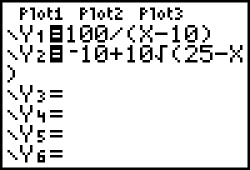

The next screen shows the two graphs in the window 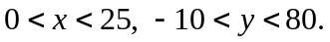

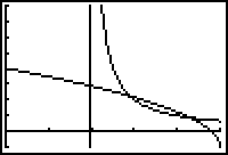

To find the left-hand intersection point, we plot in the window 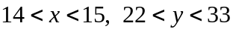 and then use the calculator's 2nd Calc intersect function:

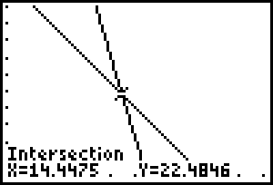

Thus we see that 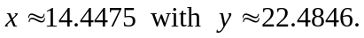 When we similarly zoom in on the right-hand intersection point, we find that 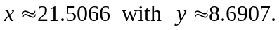 Hence the 50-ft tree may have either a low break at a height of about 14.15 feet or a high break at a height of about 21.51 feet.

Using Maple

To plot our two graphs in the window 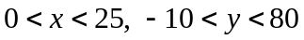 we need only enter the command

plot([100/(x-10), -10+10*sqrt(25-x)],
x = 0..25, y = -10..80, color=red);

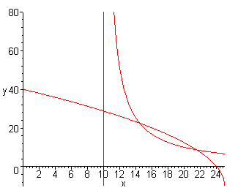

We magnify successively with the plot commands

plot([100/(x-10), -10+10*sqrt(25-x)],
x = 10..15, y = 20..25, color=red);

plot([100/(x-10), -10+10*sqrt(25-x)],
x = 14..15, y = 22..23, color=red);

plot([100/(x-10), -10+10*sqrt(25-x)],
x = 14.4..14.5, y = 22.4..22.5, color=red);

plot([100/(x-10), -10+10*sqrt(25-x)],
x = 14.44..14.45, y = 22.48..22.49, color=red);

plot([100/(x-10), -10+10*sqrt(25-x)],
x = 14.447..14.448, y = 22.484..22.485, color=red);

and see finally the figure at the top of the next page, which indicates that 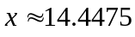
with 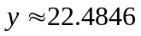 (accurate to 4 decimal places). Similarly, you can zoom in on the right-hand intersection point and find that Hence the 50-ft tree may have either a low break at a height of about 14.15 feet or a high break at a height of about 21.51 feet.

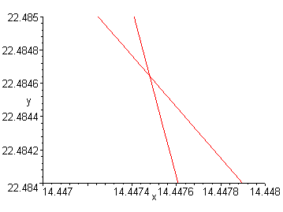

Apply each of these methods to investigate your own tree situation. The Acrobat Text Tool can be used to select the Maple commands displayed above and copy/paste them into a Maple worksheet for execution one at a time.

Using Mathematica

To plot our two graphs in the window we need only enter the command

plot([100/(x-10), -10+10*sqrt(25-x)],
x = 0..25, y = -10..80, color=red);

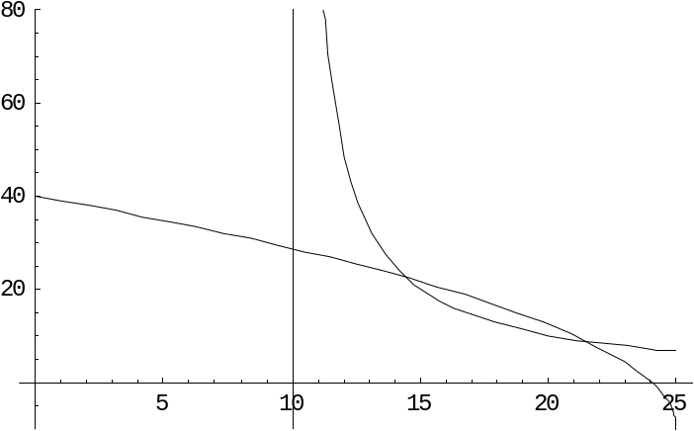

We magnify successively with the plot commands

Plot[{100/(x - 10), -10 + 10 Sqrt[25 - x]},
{x, 0, 25}, PlotRange -> {-10, 80}];
Plot[{100/(x - 10), -10 + 10*Sqrt[25 - x]},
{x, 10, 15}, PlotRange -> {20, 25}];

Plot[{100/(x - 10), -10 + 10*Sqrt[25 - x]},
{x, 14, 15}, PlotRange -> {22, 23}];

Plot[{100/(x - 10), -10 + 10*Sqrt[25 - x]},
{x, 14.4, 14.5}, PlotRange -> {22.4, 22.5}];

Plot[{100/(x - 10), -10 + 10*Sqrt[25 - x]},
{x, 14.44, 14.45}, PlotRange -> {22.48, 22.49}];

Plot[{100/(x - 10), -10 + 10*Sqrt[25 - x]},
{x, 14.447, 14.448}, PlotRange -> {22.484, 22.485}];

and see finally the figure below, which indicates that with (accurate to 4 decimal places). Similarly, you can zoom in on the right-hand intersection point and find that Hence the 50-ft tree may have either a low break at a height of about 14.15 feet or a high break at a height of about 21.51 feet.

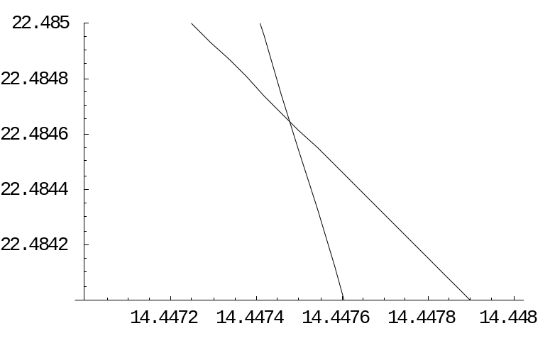

Apply each of these methods to investigate your own tree situation. The Acrobat Text Tool can be used to select the Mathematica commands displayed above and copy/paste them into a Mathematica notebook for execution one at a time.

Using MATLAB

To plot our two graphs in the window we need only enter the commands

fplot('100./(x-10)',[0 25 0 80]), grid on, hold on
fplot('-10+10*sqrt(25-x)',[0 25 0 80])

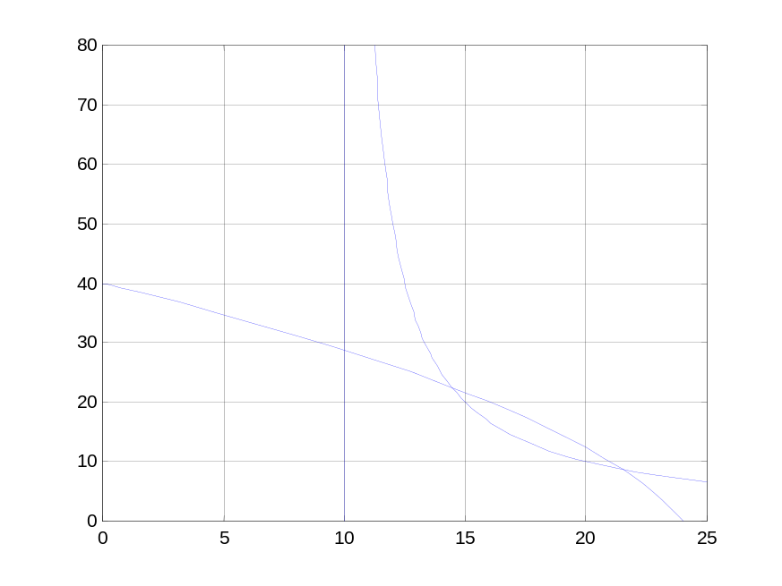

We magnify successively with the plot commands

fplot('100./(x-10)',[14 15 22 23]), grid on, hold on
fplot('-10+10*sqrt(25-x)',[14 15 22 23]), hold off

fplot('100./(x-10)',[14.4 14.5 22.4 22.5])
grid on, hold on
fplot('-10+10*sqrt(25-x)',[14.4 14.5 22.4 22.5]), hold off

fplot('100./(x-10)',[14.44 14.45 22.48 22.49])
grid on, hold on
fplot('-10+10*sqrt(25-x)',[14.44 14.45 22.48 22.49])
hold off

fplot('100./(x-10)',[14.447 14.448 22.484 22.485])
grid on, hold on
fplot('-10+10*sqrt(25-x)',[14.447 14.448 22.484 22.485]) hold off

and see finally the figure at the top of the next page, which indicates that
with (accurate to 4 decimal places). Similarly, you can zoom in on the right-hand intersection point and find that Hence the 50-ft tree may have either a low break at a height of about 14.15 feet or a high break at a height of about 21.51 feet.

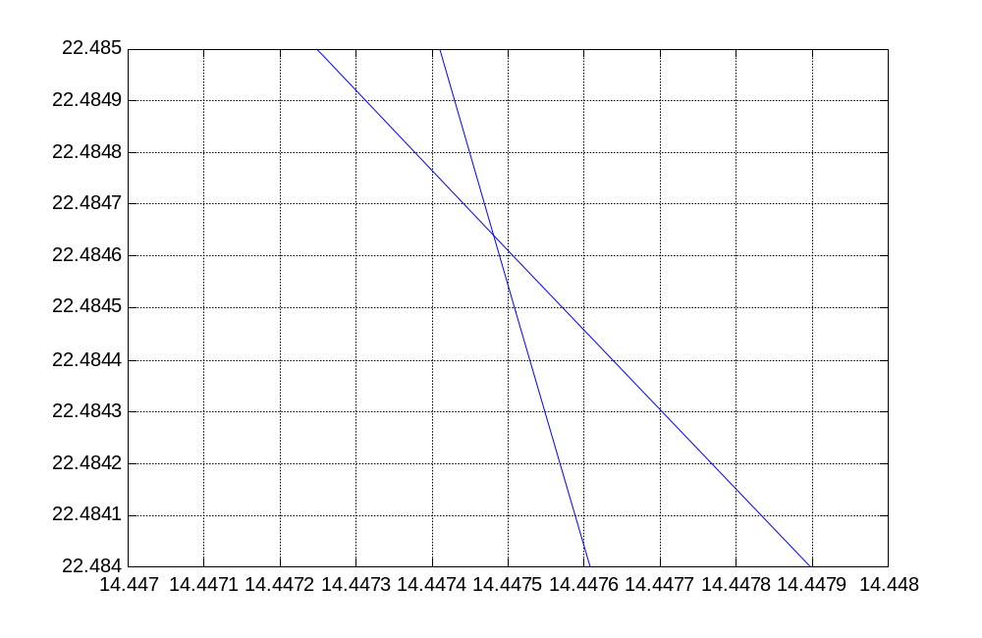

Apply each of these methods to investigate your own tree situation. The Acrobat Text Tool can be used to select the MATLAB commands displayed above and copy/paste them into a MATLAB command window for execution one at a time.

